Teacher Notes for “The Genetics of Sickle Cell Anemia and Sickle Cell Trait
– How One Gene Affects Multiple Characteristics”

In this activity, students analyze information about the molecular and cellular basis for sickle cell anemia and sickle cell trait. This provides the basis for understanding how a single gene can affect multiple phenotypic characteristics. Students also create a Punnett square, analyze a pedigree, and evaluate the relative advantages of Punnett squares and pedigrees as models of inheritance. These Teacher Notes include several optional questions which apply student understanding of the biology of sickle cell trait to practical and policy issues.

Before beginning this activity, your students should have a basic understanding of genetics, including Punnett squares. For this purpose, I recommend either:
∙ the analysis and discussion activity, “Introduction to Genetics – Similarities and Differences between Family Members” (https://serendipstudio.org/exchange/bioactivities/geneticsFR) or
∙ the hands-on activity, “Genetics” (https://serendipstudio.org/sci_edu/waldron/#genetics).

Learning Goals
In accord with the Next Generation Science Standards:
- This activity helps to prepare students for the Performance Expectation:
- HS-LS3-1, "Ask questions to clarify relationships about the role of DNA… in coding the instructions for characteristic traits passed from parents to offspring."
      - Students will gain understanding of the Disciplinary Core Idea:
- LS3.B: Variation of Traits – “In sexual reproduction, meiosis can create new genetic combinations and thus more genetic variation.”
      - Students will engage in two Scientific Practices:
- Developing and Using Models: “Develop and/or use multiple types of models to provide mechanistic accounts and/or predict phenomena, and move flexibly between model types based on merits and limitations.…”
- Constructing Explanations: “Apply scientific ideas, principles, and/or evidence to provide an explanation of phenomena…”
- This activity provides the opportunity to discuss the Crosscutting Concept:
- Cause and Effect: “Cause and effect relationships can be suggested and predicted for complex natural… systems by examining what is known about smaller scale mechanisms within the system.”

Additional Content Learning Goals
- A single gene may influence more than one phenotypic characteristic.
- The basic way that genes influence an organism's characteristics is:
Genes in DNA provide the information necessary to make proteins, and proteins carry out many biological functions and thus influence our characteristics.
- Different alleles (different versions of the same gene) code for different versions of a protein which can result in different characteristics.
- In some cases, neither allele is completely dominant or completely recessive.

Instructional Suggestions and Background Information
To maximize student learning, we recommend that you have your students complete groups of related questions in the Student Handout individually or in pairs and then have a class discussion of these questions. In each discussion, you can probe student thinking and help them to develop a sound understanding of the concepts and information covered before moving on to the next part of the activity.

If your students are learning online, we recommend that they use the Google Doc version of the Student Handout available at https://serendipstudio.org/exchange/bioactivities/geneticsSCA. To answer questions 2 and 7a, students can either print the relevant pages, draw on them and send pictures to you, or they will need to know how to modify a drawing online. To answer online, they can double-click on the relevant drawing in the Google Doc to open a drawing window. Then, they can use the editing tools to answer the questions. If you prepare a revised version of the Student Handout Word document, please check the format by viewing the PDF.

If you would like to have a key with the answers to the questions in the Student Handout, please send a message to iwaldron@upenn.edu. The following paragraphs provide additional instructional suggestions and background information.

How can one gene affect so many different characteristics?
The section heading is the driving question for this section of the activity. The anchoring phenomenon is presented in the table on the top of page 1 of the Student Handout, which introduces students to some of the many phenotypic effects of being heterozygous or homozygous for the sickle cell allele of the hemoglobin gene. Question 1 reinforces student awareness of the anchoring phenomenon.

The Student Handout does not mention the quaternary structure of hemoglobin or the gene for the alpha globin polypeptides, which are the same in normal and sickle cell hemoglobin. Instead, the Student Handout focuses on the gene for the beta globin polypeptides, which are different in normal and sickle | 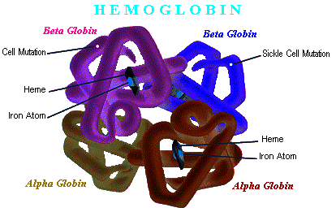  Sickle  (https://spottedtoad.files.wordpress.com/2017/06/hb3dark.gif)
cell hemoglobin.

The table on the top of page 2 of the Student Handout introduces the molecular basis for the characteristics of sickle cell anemia and sickle cell trait. The first set of arrows represents transcription and translation, the processes that use the information in a gene in the DNA to produce proteins.

If a person is homozygous for the allele for sickle cell hemoglobin, this results in sickle cell anemia. When oxygen concentration is low, sickle cell hemoglobin tends to clump into long stacks or rods of hemoglobin molecules. As a result, some of the red blood cells are distorted into abnormal shapes (sickled). The abnormally shaped red blood cells tend to clog the smaller blood vessels, thus blocking the circulation in various parts of the body. Once the local circulation is blocked, the reduced blood flow results in reduced oxygen in the blood, which causes more red blood cells to sickle, which causes more oxygen deficiency, which results in episodes of severe pain and damage to organs such as the brain, heart and kidneys. Additional aspects of the complex pathophysiology of sickle cell anemia are illustrated in the figure below.

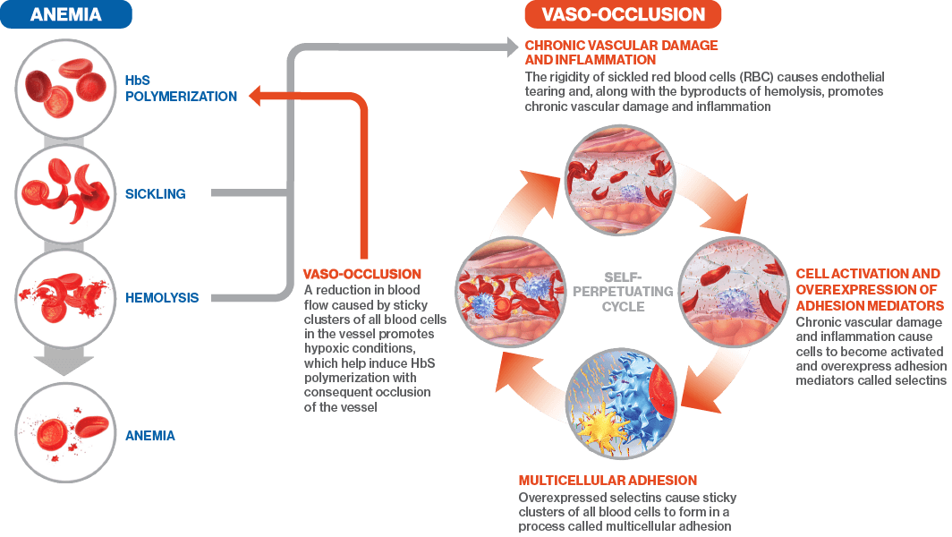(https://www.rethinkscd.com/siteassets/scd-pathophysiology/two-mechanisms-of-sickle-cell-disease.png)

For a person with sickle cell anemia, repeated sickling of the red blood cells causes mechanical stresses that result in early cell death. In a person with sickle cell anemia, red blood cells survive approximately half a month, whereas normal red blood cells survive approximately four months. Normally, the amount of red blood cells in the blood is maintained by a negative feedback mechanism (see figure below). However, in sickle cell anemia, the bone marrow cannot produce replacement red blood cells quickly enough to maintain normal levels of red blood cells, so the person has anemia (low red blood cells).
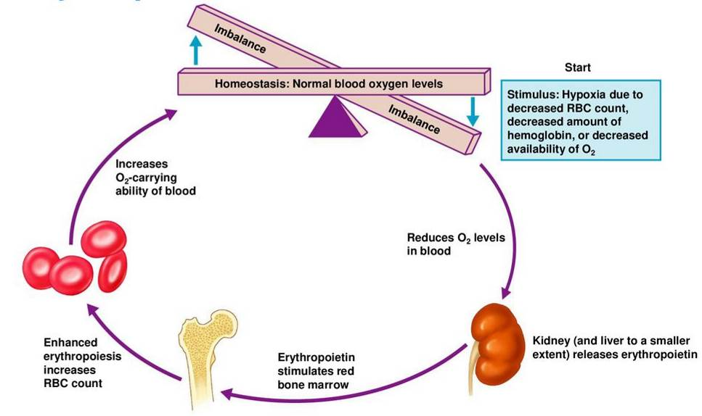
(https://slideplayer.com/slide/14131592/86/images/21/Erythropoietin+Mechanism.jpg)

Even in a person who has severe sickle cell anemia, most red blood cells are not sickled. The degree of clumping of sickle cell hemoglobin and the amount of sickling of red blood cells are influenced by multiple factors, including other genes, oxygen levels in the blood, and dehydration. For example, a sickling crisis with pain and organ damage can be triggered by an infection that induces vomiting and diarrhea, resulting in dehydration; dehydration increases the hemoglobin concentration in red blood cells and thus increases the tendency of sickle cell hemoglobin to clump into long rods and produce sickled red blood cells which block the circulation in the small blood vessels. These observations illustrate how environment and genotype interact to influence phenotype.

Careful answers to question 2a will provide important information for students to use to successfully complete the flowchart for question 2b. Question 2b requires students to integrate and synthesize the information about the molecular, cellular and health effects of the hh genotype. This question provides an excellent opportunity for small group work, using whiteboards or Jamboards to display their flowcharts. This should be followed by a discussion of the small groups’ flowcharts and then the opportunity for each group to revise their flowchart. This question provides the opportunity to reinforce the Crosscutting Concept, Cause and Effect: “Cause and effect relationships can be suggested and predicted for complex natural… systems by examining what is known about smaller scale mechanisms within the system.”

A person who has sickle cell trait is heterozygous for the sickle cell and normal hemoglobin alleles, so each red blood cell has both sickle cell and normal hemoglobin. The amount of normal hemoglobin is sufficient to prevent the symptoms of sickle cell anemia in almost all cases. This explains why the allele for normal hemoglobin is usually described as dominant. However, the normal hemoglobin allele is not completely dominant, since there is enough sickle cell hemoglobin in each red blood cell to have an important phenotypic effect. The malaria parasite grows in red blood cells, and sickle cell hemoglobin in each red blood cell slows the growth of the malaria parasite population (https://www.pnas.org/content/pnas/115/28/7350.full.pdf). In heterozygous individuals, the size of the malaria parasite population is also reduced by an interaction between sickle cell hemoglobin and malaria parasites that increases the immune system’s ability to remove infected red blood cells (https://sickle-cell.com/clinical/malaria). For these reasons, heterozygous individuals have fewer malaria parasites and less severe malaria than individuals who are homozygous for the allele for normal hemoglobin.

Malaria infections are common in many tropical countries where mosquitoes that can transmit the malaria parasite are abundant. In areas where malaria is widespread, people who are heterozygous for the sickle cell allele are less likely to become seriously ill and die. Because the sickle cell allele contributed to increased survival of heterozygous individuals, this allele became relatively common in regions like West Africa where malaria has been common. Since African-Americans are descended from populations in which the sickle cell allele was relatively common, African-Americans have relatively high rates of the sickle cell allele (approximately 8% are heterozygous for this allele and approximately 0.2% are homozygous).

Question 4 asks students to summarize the molecular mechanisms that result in the phenotypic characteristics of heterozygous individuals. The effects of the normal and sickle-cell hemoglobin alleles can be described as an example of codominance. This question provides another opportunity to discuss the Crosscutting Concept, Cause and Effect: “Cause and effect relationships can be suggested and predicted for complex natural… systems by examining what is known about smaller scale mechanisms within the system.”

You will probably want to mention that many other genes also affect multiple characteristics. This important point is often ignored in teaching introductory genetics.

Page 3 of the Student Handout recommends the video, “How This Disease Changes the Shape of Your Cells” (https://www.youtube.com/watch?v=hRnrIpUMyZQ; 4 minutes and 40 seconds). This video will reinforce student understanding of the molecular biology and physiology of sickle cell anemia and sickle cell trait; it also introduces natural selection for the sickle cell allele and the treatment of sickle cell anemia.

An informative summary of multiple aspects of sickle cell anemia and other types of sickle cell disease is provided at https://www.nhlbi.nih.gov/health-topics/sickle-cell-disease. A briefer summary of the medical aspects of sickle cell anemia is available at http://www.mayoclinic.org/diseases-conditions/sickle-cell-anemia/home/ovc-20303267. New drugs for treating sickle cell anemia are discussed in https://www.nature.com/articles/d41586-021-02141-1. If you want your students to learn about gene editing to treat sickle cell anemia, you can use the analysis and discussion activity, “Gene Editing with CRISPR-Cas – A Potential Cure for Severe Sickle Cell Anemia” (https://serendipstudio.org/exchange/bioactivities/GeneEdit). Information about sickle-cell trait is available at https://www.cdc.gov/ncbddd/sicklecell/traits.html.

Inheritance of the Sickle Cell Allele
The Punnett square analysis in question 6 will help students understand how two parents who do not have sickle cell anemia can have a child who does have sickle cell anemia. The pedigree on the same page of the Student Handout shows two such cases; this observation supports the conclusion that the allele for sickle cell hemoglobin is recessive with regard to sickle cell anemia. It should be noted that the allele for sickle cell hemoglobin is not entirely recessive, as explained above.

Question 7 asks students to predict the probability that a fourth child born to heterozygous parents 3 and 4 would have sickle cell anemia. To explain their answers, students should recall that:
- each fertilization event is independent of any previous fertilization events,
- each outcome in a Punnett square is equally likely,
- an hh offspring will have sickle cell anemia.

Question 8 asks students about the relative advantages of Punnett squares and pedigree charts as models of inheritance. These two models provide different information about inheritance.

One advantage of Punnett squares as a model of inheritance is that a Punnett square summarizes how the processes of meiosis and fertilization contribute to inheritance of different alleles of a gene. For parents with specified genotypes, Punnett squares identify what combinations of alleles their offspring can have and the resulting possible phenotypes. Punnett squares can be used to make quantitative predictions about the probability of each genotype and phenotype. Limitations of Punnett squares as models of inheritance include the lack of information about likely variation in small samples such as individual families and the lack of information about population prevalence of parental genotypes (so no predictions can be made about population prevalence of offspring genotypes and phenotypes). Also, the predictions of a Punnett square model may be inaccurate if complexities that are not included in Punnett squares play an important role in the inheritance of a specific trait (e.g., if multiple genes affect a phenotypic characteristic). The failure to take account of all the complexities is, of course, a general limitation of models, which are simplified representations of complex processes.

A pedigree chart provides information about which individuals in a multi-generation family have a certain phenotype and the relationships between these individuals. Pedigrees can be useful for figuring out the mode of inheritance for a phenotypic condition observed in multiple members of a family. Also, pedigrees can provide a useful basis for genetic counseling. Pedigrees can be quite complex to interpret, e.g., if a new mutation has occurred, if environment influences the phenotype, and/or if more than one gene influences the phenotype. Also, pedigrees do not directly represent the underlying biological processes of meiosis and fertilization.

Optional Applied Questions
The last page of these Teacher Notes presents several optional questions you may want to add at the end of the Student Handout. These questions are primarily concerned with practical and policy questions related to sickle cell trait.

Optional question 9 refers to testing newborns for sickle cell anemia and sickle cell trait. Before 2006, some newborns in the US were not tested. To learn more about the blood test for sickle cell hemoglobin, see https://www.cdc.gov/ncbddd/sicklecell/documents/factsheet_scicklecell_status.pdf.

People with sickle cell trait have an increased risk of sudden death during extremely strenuous exercise, especially in hot weather and with inadequate hydration. The number of these deaths is very small. (For example, one study found only five sudden deaths in American football players with sickle cell trait during a five-year period; during the same time period, two football players who did not have sickle cell trait died of heat stroke.) There is controversy about whether the best approach to reducing the risk of sudden death during very strenuous exercise should be required testing for sickle cell trait or greater emphasis on adequate hydration and prevention of overheating by avoiding very strenuous exercise in hot, humid environments (which would be beneficial for people with or without sickle cell trait) (https://www.ncbi.nlm.nih.gov/pmc/articles/PMC4478149/; https://www.ncbi.nlm.nih.gov/pmc/articles/PMC5049987/). Notice how environmental and behavioral factors interact with genetic factors to influence a phenotypic characteristic, the risk of sudden death.

As discussed in optional question 10, screening for sickle cell trait in teenagers who are entering high school could be helpful to prevent sudden deaths during extreme exertion and to alert young people to the risk of having a baby with sickle cell anemia. Even those who were born after newborn screening was mandated should be screened, because the family is not always informed if their newborn has sickle cell trait.

As discussed in optional question 11, many Nigerian clinicians and religious leaders discourage marriages in which both partners have sickle cell trait; this is one way to avoid having a child with sickle cell anemia in a country where there are few resources for treating sickle cell anemia and a relatively high prevalence of sickle cell trait. In the US, there are more resources for treating sickle cell anemia, but nevertheless many patients experience substantial pain and shorter lifespans. For romantic partners in the US, one way to prevent the birth of a child with sickle cell anemia is to screen both partners and, if both have sickle cell trait, use in vitro fertilization followed by genetic testing of the embryos and implanting only the embryos that are not homozygous for the sickle cell allele (https://www.rmact.com/fertility-blog/how-ivf-and-genetic-testing-can-prevent-sickle-cell-anemia).

Source for Student Handout Figures
Figures on pages 1 and 2 were modified from https://www.nhlbi.nih.gov/health-topics/sickle-cell-disease. Other figures were prepared by the author.

Additional Genetics Learning Activities
Genetics – Major Concepts and Learning Activities https://serendipstudio.org/exchange/bioactivities/GeneticsConcepts
Part I summarizes key concepts in genetics. Part II presents common misconceptions. Part III recommends an integrated sequence of learning activities on the biological basis of genetics, plus seven human genetics learning activities. These learning activities develop student understanding of key concepts and counteract common misconceptions. Each of these recommended learning activities supports the Next Generation Science Standards (NGSS; https://www.nextgenscience.org/).
Optional Questions you may want to add at the end of the Student Handout

Practical Applications

9. Currently, all newborns in the US are tested for sickle cell anemia and sickle cell trait. If a person has sickle cell anemia, he or she will usually experience symptoms that will lead to a diagnosis. Explain why a person who has sickle cell trait is probably unaware of this condition unless he or she has been tested and informed.

In the US, people with sickle cell trait have the same life expectancy as the general population. However, people with sickle cell trait have a greater risk of sudden death during extremely strenuous exercise (e. g., Division I football or basic training in the military). These deaths are very rare, but tragic when they occur. Sudden death can almost always be prevented if the exercising person consumes adequate fluids and avoids excessive overheating. These same precautions are important to prevent sudden death for people who don't have sickle cell trait.

10. Although currently there is a requirement that all US newborns be screened for sickle cell trait, often teens and young adults with sickle cell trait are not aware that they have this condition. Give two reasons why it could be useful to test all teenagers for sickle cell trait when they enter high school.

11a. Evaluate the advantages and disadvantages of the following proposals and practices for people in Nigeria.
“Increasingly, Nigerians are being urged to get a simple blood test to see if they carry the [sickle cell allele]. … It’s common for Nigerians to consider whether a potential romantic partner has the [sickle cell allele] before moving forward with the relationship. Many clinicians and religious leaders discourage marriages of people who both carry the sickle cell trait.”

11b. Would your evaluation of these proposals and practices be different for people in the US? Explain why or why not.

By Dr. Ingrid Waldron, Dept Biology, Univ Pennsylvania, 2024. These Teacher Notes and the related Student Handout are available at https://serendipstudio.org/exchange/bioactivities/geneticsSCA.
https://www.nextgenscience.org/sites/default/files/HS%20LS%20topics%20combined%206.13.13.pdf and https://www.nextgenscience.org/sites/default/files/resource/files/Appendix%20G%20-%20Crosscutting%20Concepts%20FINAL%20edited%204.10.13.pdf
To insert text, at the top of the page, click Insert. To place text inside a box or confined area, click Text Box and drag it to where you want it. Type your text. When you are done, click Save and Close.
I have used H and h to emphasize that these are two alleles of the gene for hemoglobin. An alternative, common notation is A for the allele for normal hemoglobin and S for the allele for sickle cell hemoglobin.
For information about how to make inexpensive whiteboards and use them in your teaching, see "The $2 interactive whiteboard" and "Resources for whiteboarding" in https://fnoschese.wordpress.com/2010/08/06/the-2-interactive-whiteboard/. Some additional tips for using whiteboards are: – Coat the white boards with Endust (or similar product) before using. Every once in a while, wipe them clean and reapply Endust. – Do not use markers that are old or almost empty, since the ink from these is more difficult to erase. Black markers erase easiest. For effective erasing, it's best to erase the white boards immediately after use. – Teacher and/or students can take a picture of the information on the whiteboard if they want to save it. Jamboards for this question can be found at https://jamboard.google.com/d/1pVj4zjF7hvzWTw0zefhkxxQb9fA6nUc8UTs0cnNQ0O4/copy.
If this question is too challenging for your students, you could provide them with suggested items to organize in the correct pattern to complete the flowchart, e.g. (in alphabetical order): - red blood cells elongated (sickled cells) - sickle cell hemoglobin in red blood cells tends to clump in long rods - sickle cells block blood flow, which cuts off oxygen supply - sickle cells do not survive as long, and bone marrow can’t replace fast enough.
This is known as a heterozygote advantage, which results in a balanced polymorphism, which can maintain two different alleles in a population. In contrast, children with sickle cell anemia are the most likely to die from malaria infections (https://www.ncbi.nlm.nih.gov/pmc/articles/PMC3499995/). More information about malaria is available at https://www.cdc.gov/malaria/about/index.html.
The much larger number of heterozygous individuals than homozygous individuals is a general phenomenon for alleles that are relatively rare (https://www.ncbi.nlm.nih.gov/pmc/articles/PMC3499995/).
Another point that is often ignored in teaching introductory genetics is that a single characteristic is often influenced by multiple genes. Examples of multiple genes interacting to influence a single characteristic are analyzed in “Introduction to Genetics – Similarities and Differences between Family Members” (https://serendipstudio.org/exchange/bioactivities/geneticsFR) and "Soap Opera Genetics – Genetics to Resolve Family Arguments" (https://serendipstudio.org/exchange/bioactivities/SoapOperaGenetics).
An alternative interpretation is that these two cases were both due to new mutations, but this is unlikely since mutations are rare.
Many students tend to think of a model as a physical object and may not understand that a Punnett square or pedigree chart is a model of inheritance. You may want to introduce the idea of a conceptual model. "Conceptual models allow scientists… to better visualize and understand a phenomenon under investigation… Although they do not correspond exactly to the more complicated entity being modeled, they do bring certain features into focus while minimizing or obscuring others. Because all models contain approximations and assumptions that limit the range of validity of their application and the precision of their predictive power, it is important to recognize their limitations." If your students are not familiar with conceptual models, you may want to give examples of conceptual models that students may have used, e. g, a map, a diagram of a football play, or an outline for a paper the student is writing. (Quotation from A Framework for K-12 Science Education: Practices, Crosscutting Concepts, and Core Ideas http://www.nap.edu/catalog.php?record_id=13165)
Students learn this in either recommended prerequisite activity (https://serendipstudio.org/exchange/bioactivities/geneticsFR or https://serendipstudio.org/sci_edu/waldron/#genetics).
Examples of these complexities are discussed in "Introduction to Genetics – Similarities and Differences between Family Members" (which discusses how multiple genes influence height; https://serendipstudio.org/exchange/bioactivities/geneticsFR). Another example of complexity is eye color. Two blue-eyed parents generally do not have brown-eyed children because the most common allele responsible for blue eyes is recessive. However, exceptions can occur due to complex interactions between the multiple genes that influence eye color or due to mutation (which can reverse the point mutation generally responsible for blue eyes). For an introductory explanation and video, see http://genetics.thetech.org/ask/ask29; for a more complete discussion, see http://sciencecases.lib.buffalo.edu/cs/collection/detail.asp?case_id=562&id=562.
There are several other disorders that potential reproductive partners should be screened for (https://www.cdc.gov/ncbddd/sicklecell/documents/Sickle-Cell-Infographic.pdf).
Quotation from New York Times, December 21, 2021, page D8

